* **C# Program to Check Whether a Given Number is Even or Odd**

using System;

public class HelloWorld

{

public static void Main(string[] args)

{

Console.WriteLine ("Enter a number:");

int num=int.Parse(Console.ReadLine());

if(num%2==0)

{

Console.WriteLine("number is even");

}

else{

Console.WriteLine("number is odd");

}

}

}

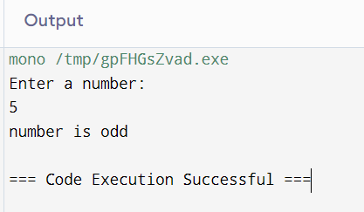

* **C# Program to Print Odd Numbers in a Given Range**

using System;

public class HelloWorld

{

public static void Main(string[] args)

{

Console.WriteLine ("Enter the start number:");

int num1=int.Parse(Console.ReadLine());

Console.WriteLine("Enter the end number");

int num2=int.Parse(Console.ReadLine());

Console.WriteLine("odd number from given range:");

for(int i=0;i<=num2;i++)

{

if(i%2!=0)

{

Console.WriteLine(i);

}

}

}

}

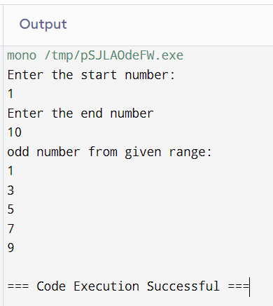

* **C# Program to Check Whether a Number is Positive or Not**

using System;

public class HelloWorld

{

public static void Main(string[] args)

{

Console.WriteLine ("Enter the number");

int num=int.Parse(Console.ReadLine());

// Console.WriteLine("Enter the end number");

//int num2=int.Parse(Console.ReadLine());

if(num>=0)

{

Console.WriteLine("number is positive");

}

else{

Console.WriteLine("number is negative");

}

}

}

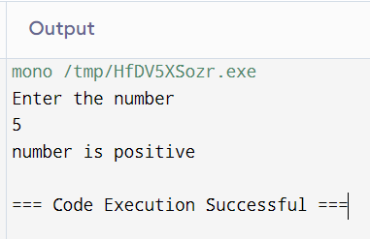

* **C# Program to Find the Largest of Two Numbers**

using System;

public class HelloWorld

{

public static void Main(string[] args)

{

Console.WriteLine ("Enter first number");

int num1=int.Parse(Console.ReadLine());

Console.WriteLine("Enter second number");

int num2=int.Parse(Console.ReadLine());

if(num1>num2)

{

Console.WriteLine($"num1 is greter");

}

else{

Console.WriteLine($"num2 is greter");

}

}

}

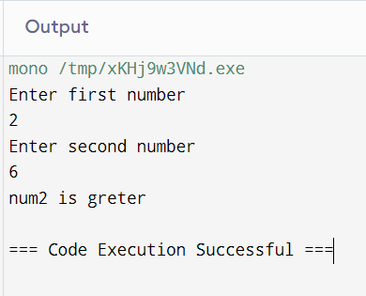

* **C# Program to Swap Two Numbers**

using System;

public class HelloWorld

{

public static void Main(string[] args)

{

int z;

Console.WriteLine ("Enter first number");

int x=int.Parse(Console.ReadLine());

Console.WriteLine("Enter second number");

int y=int.Parse(Console.ReadLine());

z=x;

x=y;

y=z;

Console.WriteLine("x="+x);

Console.WriteLine("y="+y);

}

}

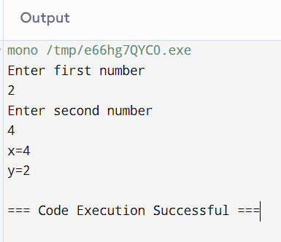

* **C# Program to Check if a Number is Divisible by 2**

using System;

public class HelloWorld

{

public static void Main(string[] args)

{

Console.WriteLine ("Enter the number");

int x=int.Parse(Console.ReadLine());

if(x%2==0)

{

Console.WriteLine("the number is divisible by 2");

}

else{

Console.WriteLine("number does not divisible by 2");

}

}

}

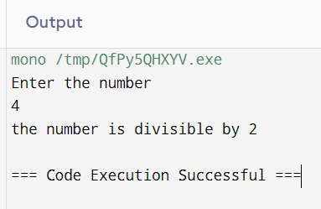

* **C# Program to Find the Sum of All the Multiples of 3 and 5**

using System;

public class HelloWorld

{

public static void Main(string[] args)

{

int[] arr={1,12,15,30,7,8,6};

int sum=0;

for(int i=0;i<arr.Length;i++)

{

if(arr[i]%3==0 && arr[i]%5==0)

{

sum+=arr[i];

}

}

Console.WriteLine(+sum+" is sum of number which is divisible by 3 and 5");

}

}

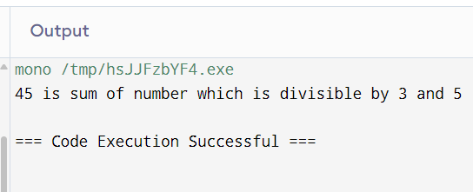

* **C# Program to Find Sum of Digits of a Number**

using System;

public class HelloWorld

{

public static void Main(string[] args)

{

Console.WriteLine("enter the number");

int num=int.Parse(Console.ReadLine());

int digit,sum=0;

while(num!=0)

{

digit=num%10;

sum+=digit;

num=num/10;

}

Console.WriteLine(+sum+" is the sum of the digit of give number");

}

}

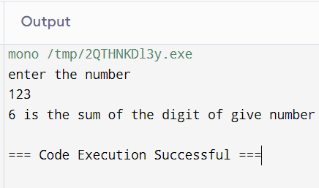

* **C# Program to Reverse a Number**

using System;

public class HelloWorld

{

public static void Main(string[] args)

{

Console.WriteLine("enter the number");

int num=int.Parse(Console.ReadLine());

int digit,sum=0;

while(num!=0)

{

digit=num%10;

Console.Write(+digit);

num=num/10;

}

}

}

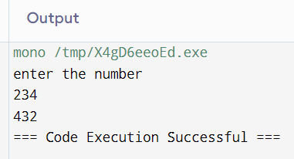

* **C# Program to Reverse a Number and Check if it is a Palindrome**

using System;

public class HelloWorld

{

public static void Main(string[] args)

{

Console.WriteLine("enter the number");

int num=int.Parse(Console.ReadLine());

int digit,rev=0,n=num;

while(num!=0){

digit=num%10;

rev=rev*10+digit;

num=num/10;

}

if(n==rev)

{

Console.WriteLine("the number is palindrom");

}

}

}

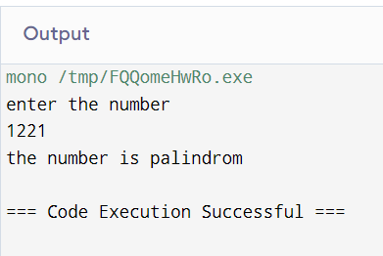

* **C# Program to Calculate the Sum, Multiplication, Division and Subtraction of Two Numbers(use switch case)**

using System;

public class HelloWorld

{

public static void Main(string[] args)

{

int result;

Console.WriteLine("enter the number");

int num1=int.Parse(Console.ReadLine());

Console.WriteLine("enter the number");

int num2=int.Parse(Console.ReadLine());

Console.WriteLine("select operation 1.AADITION 2.SUBSTRACTION 3.MULTIPLICATION 4.DIVISION");

int ch= int.Parse(Console.ReadLine());

switch(ch){

case 1:

Console.WriteLine("Addition");

result=num1+num2;

Console.WriteLine("result"+result);

break;

case 2:

Console.WriteLine("Substraction");

result=num1-num2;

Console.WriteLine("result"+result);

break;

case 3:

Console.WriteLine("Multiplication");

result=num1*num2;

Console.WriteLine("result"+result);

break;

case 4:

Console.WriteLine("Division");

result=num1/num2;

Console.WriteLine("result"+result);

break;

}

}

}

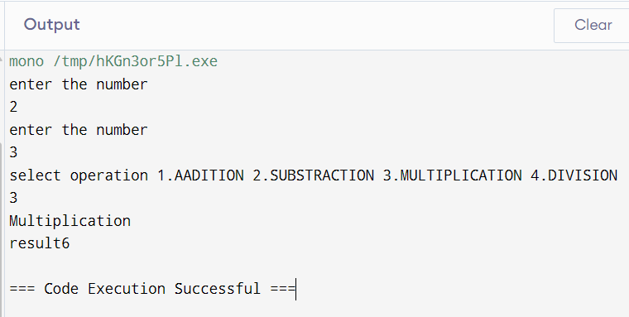

* **C# Program to Generate Fibonacci Series**

using System;

public class HelloWorld

{

public static void Main(string[] args)

{

int n1=0,n2=1,n3,i,count=5;

Console.WriteLine("Fibonacci is:");

for(i=0;i<count;i++)

{

n3=n1+n2;

Console.WriteLine(+n3);

n1=n2;

n2=n3;

}

}

}

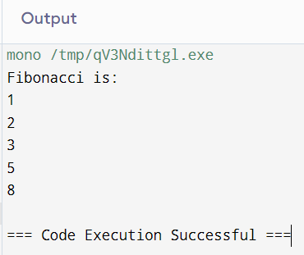

* **# Program to Print the Factorial of a Given Number**

using System;

public class HelloWorld

{

public static void Main(string[] args)

{

int i,fact=1;

Console.WriteLine("enter number");

int num=int.Parse(Console.ReadLine());

for(i=1;i<=num;i++)

{

fact=fact*i;

}

Console.WriteLine("factorial of given number is "+fact);

}

}

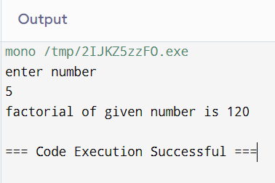

* **C# Program to Print All the Prime Numbers between 1 to 100**

**using System;**

public class HelloWorld

{

public static void Main(string[] args)

{

for(int num=1;num<=100;num++)

{

bool isPrime=true;

if(num==1)

{

isPrime=false;

}else

{

for(int i=2;i<=num/2;i++)

{

if(num%i==0)

{

isPrime=false;

break;

}

}

}

if(isPrime)

{

Console.Write(+num+" ");

}

}

}

}

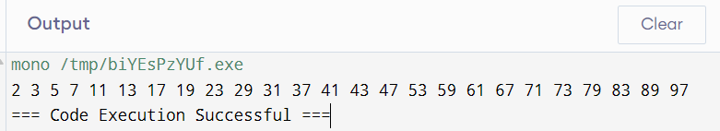

* **C# Program to Find the Largest Prime Factor of a Number**

using System;

public class HelloWorld

{

public static void Main(string[] args)

{

Console.WriteLine ("Enter any number to check largest prime number");

int num=int.Parse(Console.ReadLine());

int n=num;

int k=2;

while(k*k<=num){

if(num%k==0){

num/=k;

}else

{

++k;

}

}

Console.WriteLine("largest prime number of "+n+"is:"+num);

Console.ReadLine();

}

}

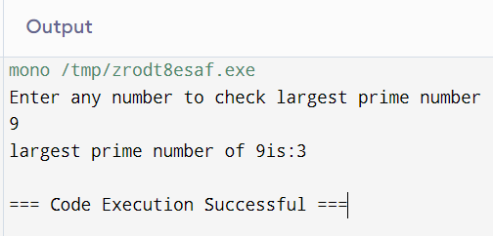

* **C# Program to Check Whether a Given Number is Perfect Number**

// Online C# Editor for free

// Write, Edit and Run your C# code using C# Online Compiler

using System;

public class HelloWorld

{

public static void Main(string[] args)

{

Console.WriteLine ("Enter number");

int num=int.Parse(Console.ReadLine());

int sum=0;

for(int i=1;i<num;i++)

{

if(num%i==0)

{

sum+=i;

}

}

if(sum==num)

{

Console.WriteLine("number is perfect");

}else

{

Console.WriteLine("the number is not a perfect number");

}

}

}

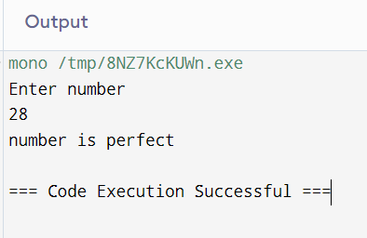

* **C# Program to Check Armstrong Number**

using System;

public class HelloWorld

{

public static void Main(string[] args)

{

Console.WriteLine ("Enter number");

int number=Convert.ToInt32(Console.ReadLine());

int sum = 0;

int originalNumber = number;

int digits = 0;

while(number!=0)

{

number /= 10;

digits++;

}

number = originalNumber;

while(number!=0)

{

int remainder = number % 10;

sum += Convert.ToInt32(Math.Pow(remainder, digits));

number /= 10;

}

if(sum == originalNumber)

{

Console.WriteLine(originalNumber + " is an Armstrong Number");

}

else

{

Console.WriteLine(originalNumber + " is not an Armstrong Number");

}

}

}

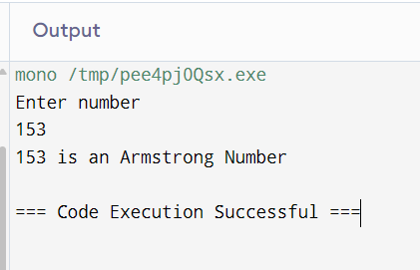

* **C# Program to Print Armstrong Number between 1 to 1000**

using System;

public class HelloWorld

{

public static void Main(string[] args)

{

Console.WriteLine ("Enter the number");

int remd,n,sum,i;

Console.WriteLine("Armstrong Number");

for(i=1;i<=1000;i++)

{

n=i;

sum=0;

while(n!=0)

{

remd=n%10;

sum=sum+(remd*remd*remd);

n=n/10;

}

if(sum==i){

Console.Write(i+" ");

}

}

}

}

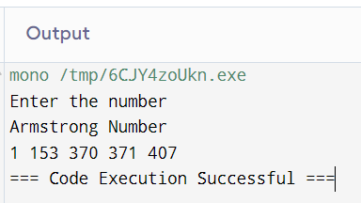

* **C# Program to Generate the Sum of N Numbers**

using System;

public class HelloWorld

{

public static void Main(string[] args)

{

int sum=0,i;

Console.WriteLine("Enter the value of num ");

int num=int.Parse(Console.ReadLine());

for(i=1;i<=num;i++)

{

sum+=i;

}

Console.WriteLine("sum of the natural number="+sum);

}

}

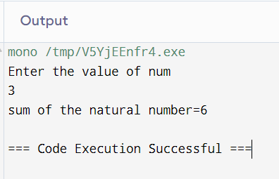

* **C# Program to Find the Sum of First 50 Natural Numbers using For Loop**

using System;

public class HelloWorld

{

public static void Main(string[] args)

{

int sum=0,i;

for(i=1;i<50;i++)

{

sum+=i;

}

Console.WriteLine("sum of the first 50 natural number="+sum);

}

}

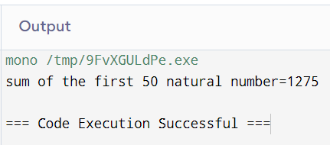

* **C# Program to Find the Sum of Two Binary Numbers**

using System;

public class HelloWorld

{

public static void Main(string[] args)

{

Console.WriteLine ("Enter the first binary number");

string num1=Console.ReadLine();

Console.WriteLine ("Enter the second binary number");

string num2=Console.ReadLine();

int n1=Convert.ToInt32(num1,2);

int n2=Convert.ToInt32(num2,2);

int sum=n1+n2;

string binarySum=Convert.ToString(sum,2);

Console.WriteLine("the sum of two binary number is"+binarySum);

}

}

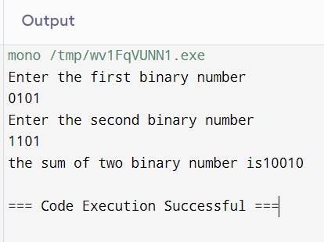

* **C# Program to Multiply Two Binary Numbers**

using System;

public class HelloWorld

{

public static void Main(string[] args)

{

Console.WriteLine ("Enter the first binary number");

string num1=Console.ReadLine();

Console.WriteLine ("Enter the second binary number");

string num2=Console.ReadLine();

int n1=Convert.ToInt32(num1,2);

int n2=Convert.ToInt32(num2,2);

int mul=n1*n2;

string binaryMul=Convert.ToString(mul,2);

Console.WriteLine("the multiplication of two binary number is"+binaryMul);

}

}

